Requirement Analysis
Technology Stack
Date | 12 July 2026
Team ID | SWTID-2026-4644
Project Name | Smart Lender
Phase | 2. Requirement Analysis

Overview
Smart Lender follows a layered architecture: a presentation layer (HTML/CSS/JS templates), an application layer (Flask routing and a dedicated prediction service module), a machine learning layer (a persisted scaler and classifier), and a data layer (source dataset and preprocessing artifacts). Cloud hosting is shown as a proposed layer, since the current codebase runs locally via Flask's development server.
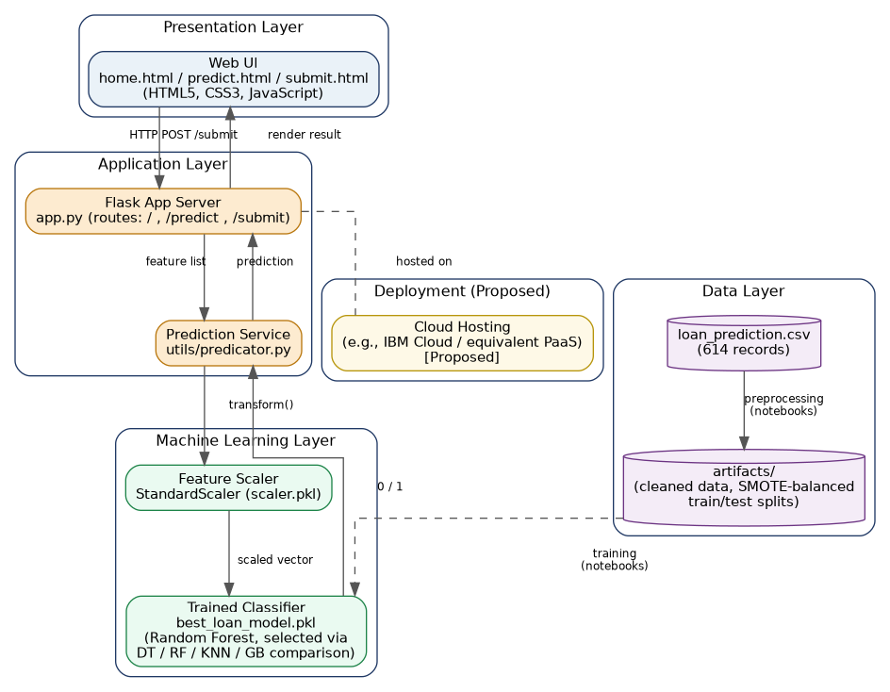
Figure 1: Layered Solution Architecture.

Table 1: Components & Technologies
Component | Description | Technology
User Interface | Applicant-facing web form and result page | HTML5, CSS3, JavaScript (templates/, static/)
Application Logic | Routing, form parsing, categorical encoding, orchestration | Python, Flask (app.py)
Prediction Service | Loads trained model/scaler once; exposes predict_loan() | Python module (utils/predicator.py)
Machine Learning Model | Classifies applicants as eligible / not eligible | Random Forest Classifier, scikit-learn (best_loan_model.pkl)
Feature Scaling | Normalizes features to match training-time distribution | StandardScaler, scikit-learn (scaler.pkl)
Class Balancing (training) | Corrects approve/reject class imbalance | SMOTE, imbalanced-learn
Data Storage | Historical records and preprocessing artifacts | CSV + joblib/pickle (dataset/, artifacts/, models/)
Experimentation | Interactive preprocessing & model comparison | Jupyter Notebook (notebooks/)
Cloud Database | Not used in the current implementation | N/A — Not Implemented
External API | No external API is called | N/A — Not Implemented
Infrastructure | Local dev via Flask server; production hosting not configured | [Proposed] IBM Cloud or equivalent PaaS

Table 2: Application Characteristics
Characteristic | Description
Open-Source Frameworks | Flask, scikit-learn, pandas, NumPy, imbalanced-learn — all open-source, free to audit and run.
Security | No authentication or input-sanitization layer exists yet. [Recommended] HTTPS, input validation, CSRF protection.
Scalability | Stateless Flask routes support horizontal scaling. [Proposed] Multiple WSGI workers behind a load balancer.
Availability | Single-process, no redundancy today. [Proposed] Managed cloud hosting with auto-restart and multiple instances.
Performance | Single lightweight classifier inference on 11 features — well within typical web request timeouts.

Rationale for Technology Choices
- Flask was chosen for its minimal footprint and direct fit with a small, model-serving web app — no unnecessary framework overhead for a single-purpose prediction service.
- scikit-learn covers the full modeling need (four classifier families, cross-validation, persistence via joblib) without requiring a heavier framework like TensorFlow/PyTorch, appropriate for a tabular, non-deep-learning problem.
- imbalanced-learn's SMOTE was chosen specifically because the dataset's approve/reject classes are imbalanced, and naive training would bias the model toward the majority class.

